**Module-2: EC2 and EFS Assignment - 3**

You have been asked to: Create an EFS and connect it to 3 different EC2 instances. Make sure all instances have different Operating System. For instance, Ubuntu, Red Hat Linux and Amazon Linux 2

Answer:

First I have created 3 instances with different operating systems and they are available to use now.

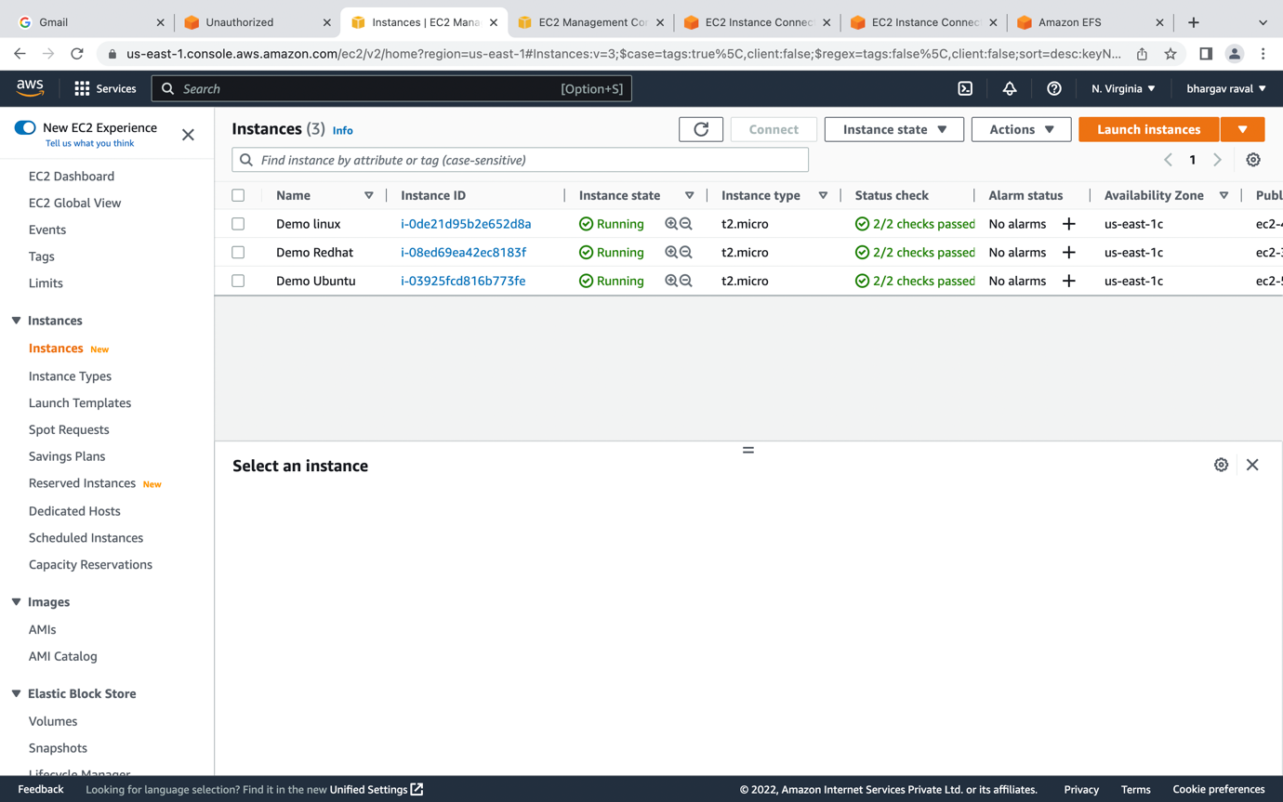

Then I have created Demo EFS and its available to use now

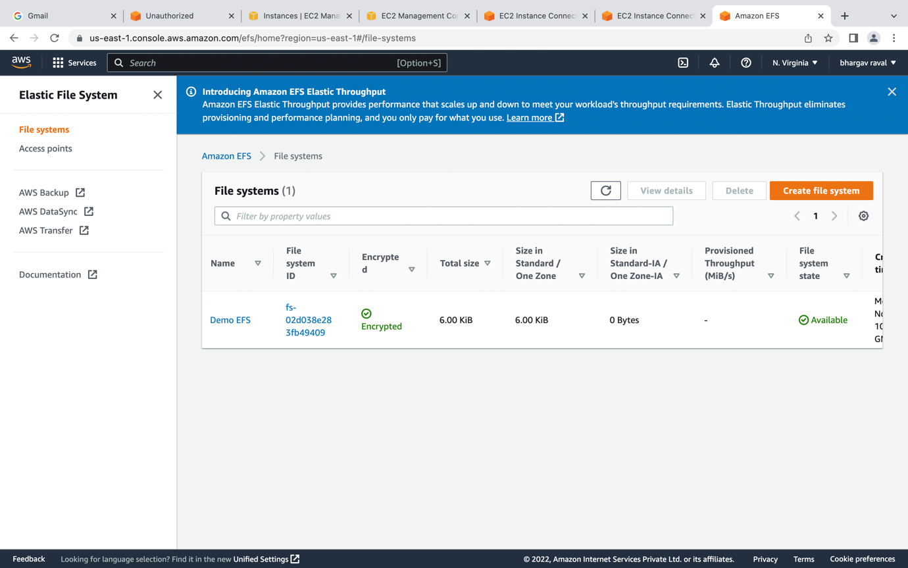

Then when you click on Demo EFS, you will see the tab called attach EFS, click on that then you will see below screen, this command we use to mount the EFS in all three Operating Systems

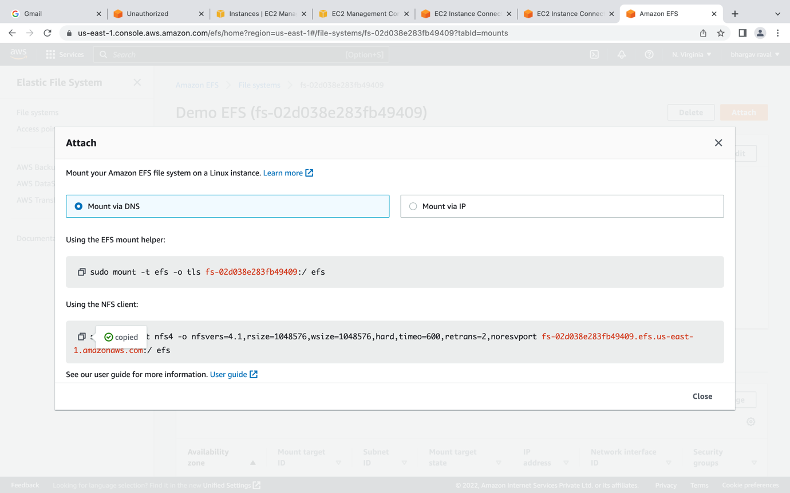

For Redhat Linux, use the command

Sudo yum install nfs-utils -y to install nfs then make directory call EFS using Sudo mkdir EFS then use the mount command

sudo mount -t nfs4 -o nfsvers=4.1,rsize=1048576,wsize=1048576,hard,timeo=600,retrans=2,noresvport fs-02d038e283fb49409.efs.us-east-1.amazonaws.com:/ efs

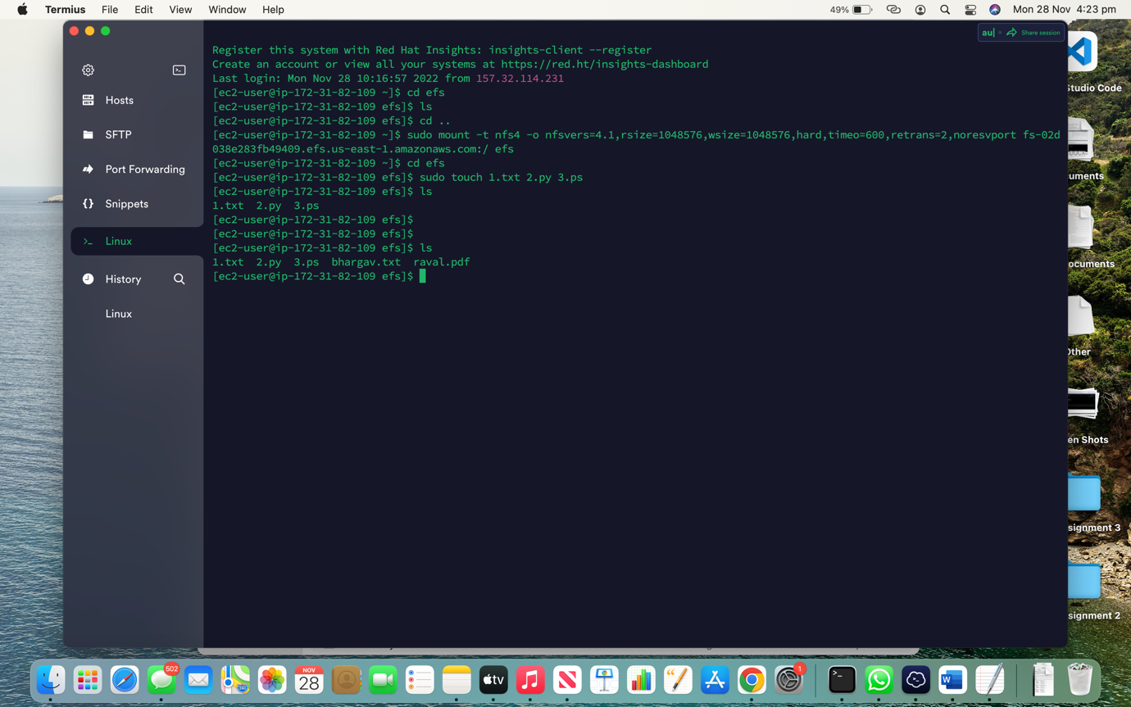

Then for Amazon Linux use

Sudo yum install amazon-efs-utils -y to install EFS then create directory call EFS using sudo mkdir EFS then mount the EFS using this command

sudo mount -t nfs4 -o nfsvers=4.1,rsize=1048576,wsize=1048576,hard,timeo=600,retrans=2,noresvport fs-02d038e283fb49409.efs.us-east-1.amazonaws.com:/ efs

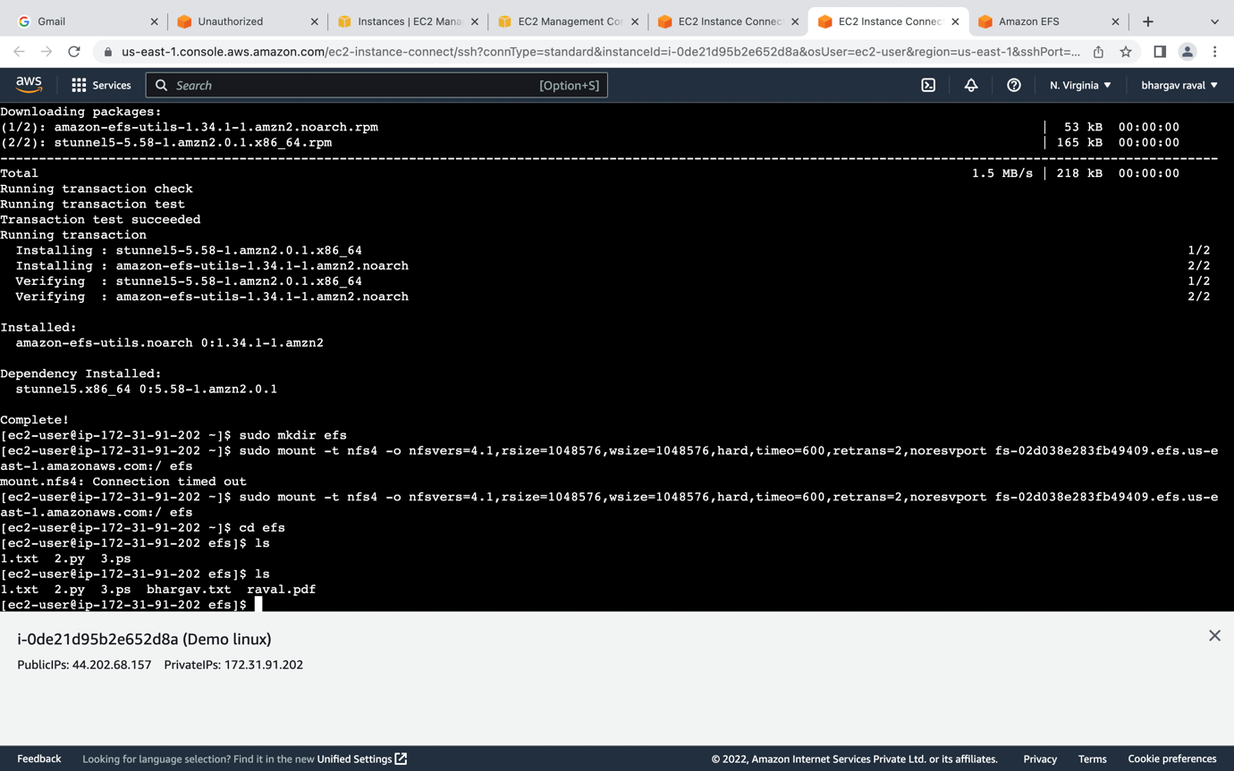

Then in Ubuntu use,

Sudo apt-get install nfs-common -y to install EFS then make directory call EFS using sudo mkdir EFS then mount the EFS using this command

sudo mount -t nfs4 -o nfsvers=4.1,rsize=1048576,wsize=1048576,hard,timeo=600,retrans=2,noresvport fs-02d038e283fb49409.efs.us-east-1.amazonaws.com:/ efs

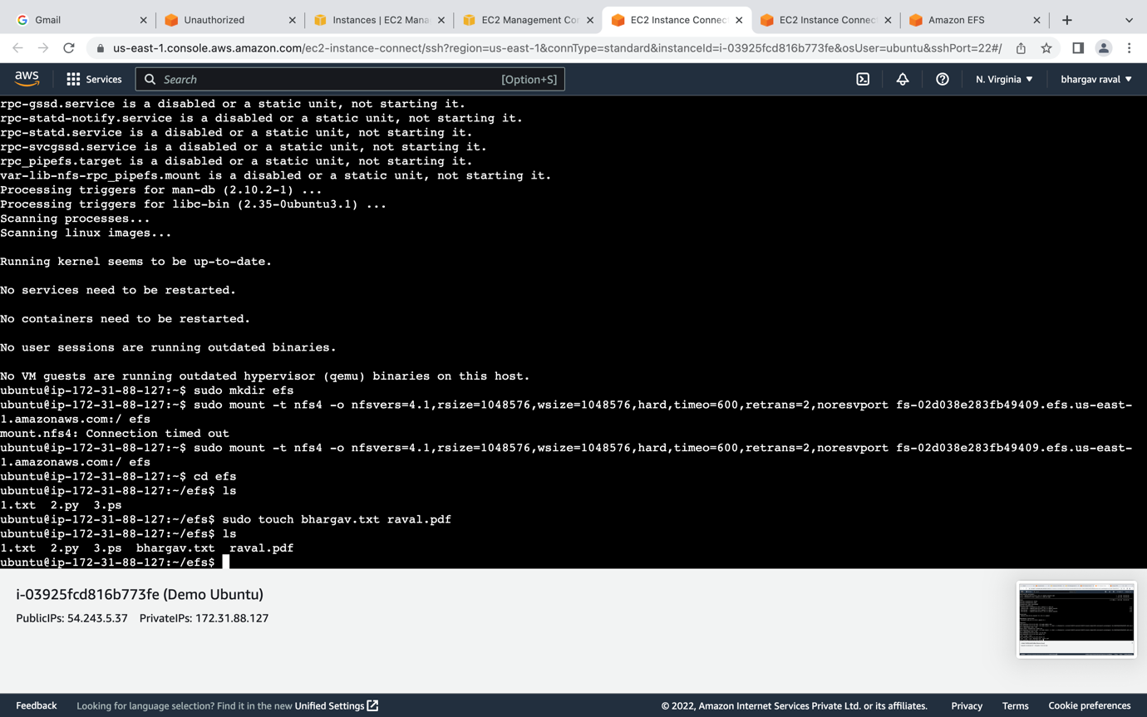

After mounting the EFS in all three OS, go to EFS using cd EFS then inside EFS directory use touch command to create empty file such as sudo touch 1.txt, 2.py, 3.ps then all files will be available in all the OS because we have mounted the EFS in all of them so they will share the resources at same time.